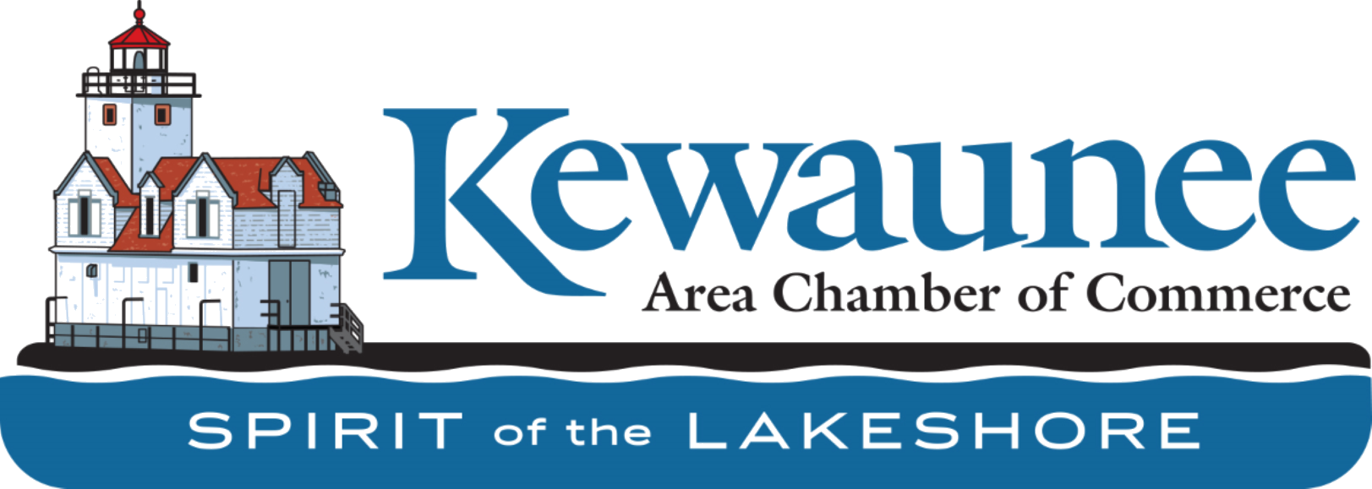

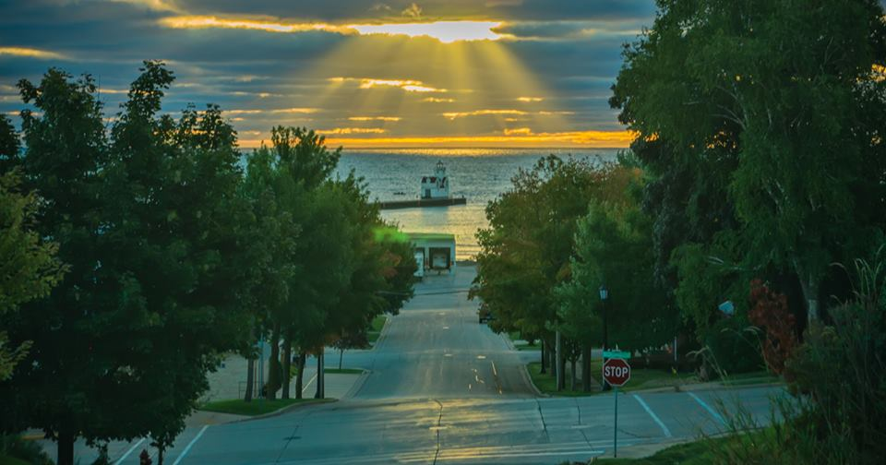
Greetings Chamber Members!  Thank you for being members of the Kewaunee Area Chamber of Commerce. Our Mission is “To provide the leadership necessary to promote Kewaunee’s tourism, business, and industrial development while preserving its maritime heritage.” | Kewaunee.org  Send us your events to get added to the calendar on our website!  Send us an email with all your details or call Renae at 920-388-4822. |  | Volunteers Needed  We are still in need of volunteer bartenders for the July 3rd event this Saturday! Can you help? Call or email us right away!
Make sure to follow us on Facebook and Instagram:
Kewaunee Area Chamber of Commerce | Facebook

KACC (@kewauneeareachamberofcommerce) • Instagram photos and videos

Save the Dates!
June/July Events!

**For more details on the events below go to www.kewaunee.org

A huge THANK YOU to our sponsors for the July 3rd event coming up this weekend!! We are not able to put on events without your support and generosity!

Accurate Marine and Storage
Bob’s Auto Part’s
Pagel’s Ponderosa
Muskrat City
Baptist Community Church

July 1st– 7:00pm-9:00pm Algoma Concerts in the Park – event runs weekly

july 2nd – Yoga in the Vineyard – door 44 10:00am-11:00am – event runs weekly

July 3rd – Yoga in the Vineyard – Parallel 44 10:00am-11:00am – event runs weekly

July 3rd – Mimosas and Music – Parallel 44 11:00am-2:00pm – Event runs weekly

July 3rd – Fireworks at the Shore – Lakehaven Hall – 11:00am until Dusk
July 4th – Kewaunee Music in the Park – 5:00-7:30pm
July 10th – Kewaunee Veterans Car Show, vintage snowmobile show and tractor show, 9:00am – 4:00pm
July 9th-11th – Kewaunee County Fair
July 10th-Beer and Yoga – Ahnapee Brewery – 11:00am-12:00pm
July 17th – KHS Alumnifest – 12:00pm until 10:00pm

July 22nd-31st – K/D Salmon Tournament

Hope to see everyone this Saturday!
11:00 AM Food and beverages will be served until dusk! Food by
Muskrat City.
3:00 PM Kids activities will start
4:00 PM Blind Ambition will play until Dusk
Fireworks at Dusk

Do you need the 2021 guides? Let us know and we would love to stop in and drop some off!

Art Walk Banners will be going up this week! Vote for the people’s choice award this summer! Ballots are available at the Chamber and at the local gas stations and you can email your choice to admin@kewaunee.org
Thank you to our Sponsors:
Lighthouse Title Harbor Express
TEAM CLEAN Zoobilee 9/25/21 Bruemmer Park
Pretty Please Boutique Kewaunee Custard
Novak Agency Kewaunee Historical Societal
Ron’s Cheese American Legion Post 29
The Bucket Kewaunee Historical Society
Don & Jean Smith Charitable Fund Waterfront Bar & Grill
